Product name | Confidentiality level
Product version | Total 8 pages

HUAWEI AR Engine Development Guide (Unity)

Prepared by | Hu Chang (employee ID: 00422988) | Date | 2018-05-10
Reviewed by |  | Date
Approved by |  | Date


Huawei Technologies CO., LTD.
All Rights Reserved

Revision Record
Date | Revision Version | CR ID/Defect ID | Section No. | Change Description | Author
2018-05-10 | 0.6 |  |  | Initial draft completed | Hu Chang (employee ID: 00422988)

Contents
1 Environmental Development Preparations 5
1.1 Hardware Preparations 5
1.2 Software Preparations 5
1.3 Debugging Program Sample 5
2 Develop AR Apps Based on HUAWEI AR Engine Unity SDK 7
2.1 Import Unity Package 7
2.2 Modify Dependency Type 7

List of Figures
Figure 1-1 Huawei AR Engine Unity project sample 5
Figure 1-2 Build Settings page 6
Figure 1-3 Demo effects 7
Figure 2-1 Dependency type modification 7

Environmental Development Preparations

Hardware Preparations
Prepare a Huawei P20 (used in this article as an example), P20 Pro, or Mate RS mobile phone, a PC, and a Type-C data cable.

Software Preparations
Install Unity 2017.3.0f3 or later and Android SDK Platform version 7.0 (API level 24) or later on your PC.
Download the HUAWEI AR Engine development kit from the official HUAWEI Developer website:
http://developer.huawei.com/consumer/cn/devservice/develop/mobile
Download the HUAWEI AR Engine Server apk from HUAWEI APP Market（search “HUAWEI AR Engine”）
Install HUAWEI AR Engine Service apk on your P20:
adb install –r "HUAWEI AR Engine Service_vx.x.x.apk"

Debugging Program Sample
Use Unity to create a project and import HUAWEI AR Engine Unity SDK_vx.x.x.unitypackage, then open the preview scene under PreviewSample > Scenes, as shown in Figure 1.
              - Huawei AR Engine Unity project sample
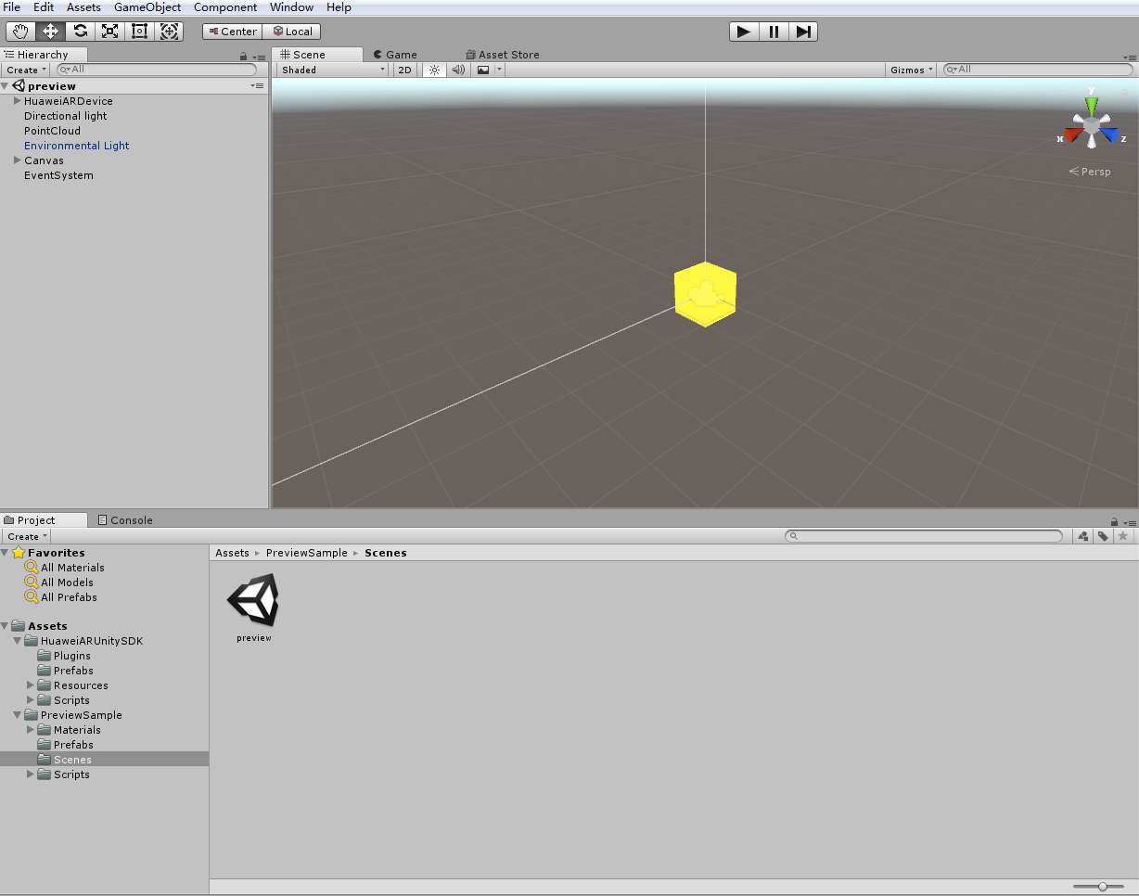

Set Build Settings, then select the scene and Android platform, as shown below (if Gradle fails to build, you can select Internal to build):
              - Build Settings page
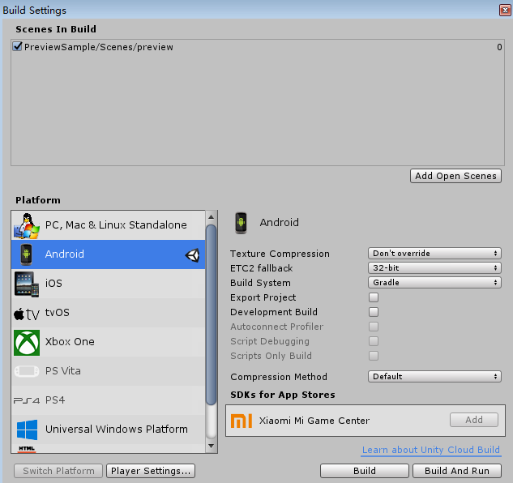

Set Player Settings and lock the required Orientation in Resolution And Presentation, then disable Multithreaded Rendering in Other Settings. Go to File > Build And Run, and Unity will automatically compile and install.
The HUAWEI AR Engine Demo will run on the P20. After authorizing the Camera permission, align the rich textured plane and slowly move the phone as Demo recognizes the plane, then touch the phone screen to place the virtual object, as shown in Figure 3.
              - Demo effects
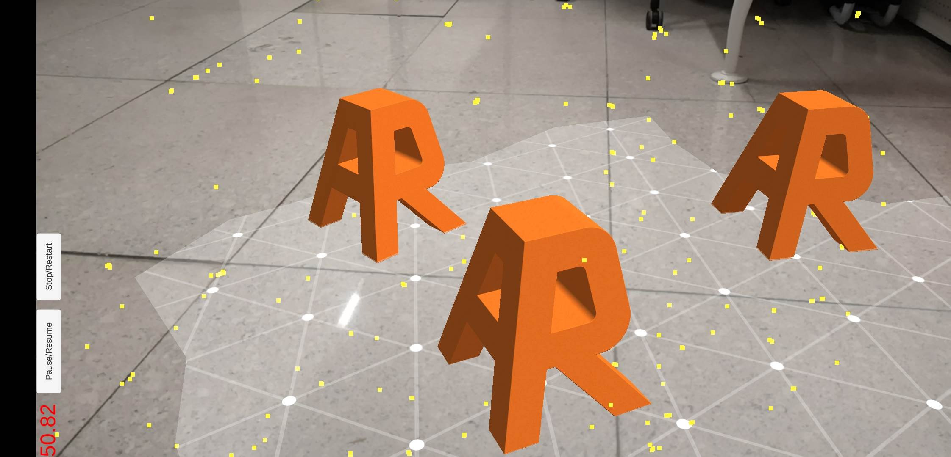

Develop AR Apps Based on HUAWEI AR Engine Unity SDK

Import Unity Package
Create a Unity project and import the HUAWEI AR Engine Unity SDK_vx.x.x.unitypackage, then refer to the PreviewSample and interface manual for development.

Modify Dependency Type
There are two types of app dependencies on HUAWEI AR Engine: optional and required.
Required dependency indicates that the app fully relies on the HUAWEI AR Engine. The app cannot be used when the device does not support HUAWEI AR Engine or when the device does not have HUAWEI AR Engine installed.
Based on the conditions, HUAWEI AppGallery will determine whether the type of Huawei device is applicable to the app or whether you need to download and install the HUAWEI AR Engine APK after downloading the app.
For required dependency, go to Edit > Project Settings > HUAWEI AR, and check Huawei AR Required.
              - Dependency type modification
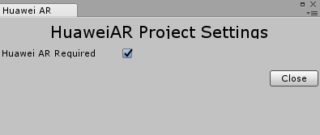

Optional dependency indicates that when your device supports HUAWEI AR Engine, the app has one or more features associated with HUAWEI AR Engine. The app can also run on devices that do not support HUAWEI AR Engine.
For optional dependency, uncheck the Huawei AR Required option in the preceding figure.

